Custom Resin Engagement Tray Order Form
Quoted price:

Please fill out the details below so we can create your dream engagement tray.

Customer Information
Full Name |  | Mobile
Instagram name |  | Email
Date of event |  | Date of pick up

Please highlight the tray shape:


Round geode Straight rectangle Oval geode
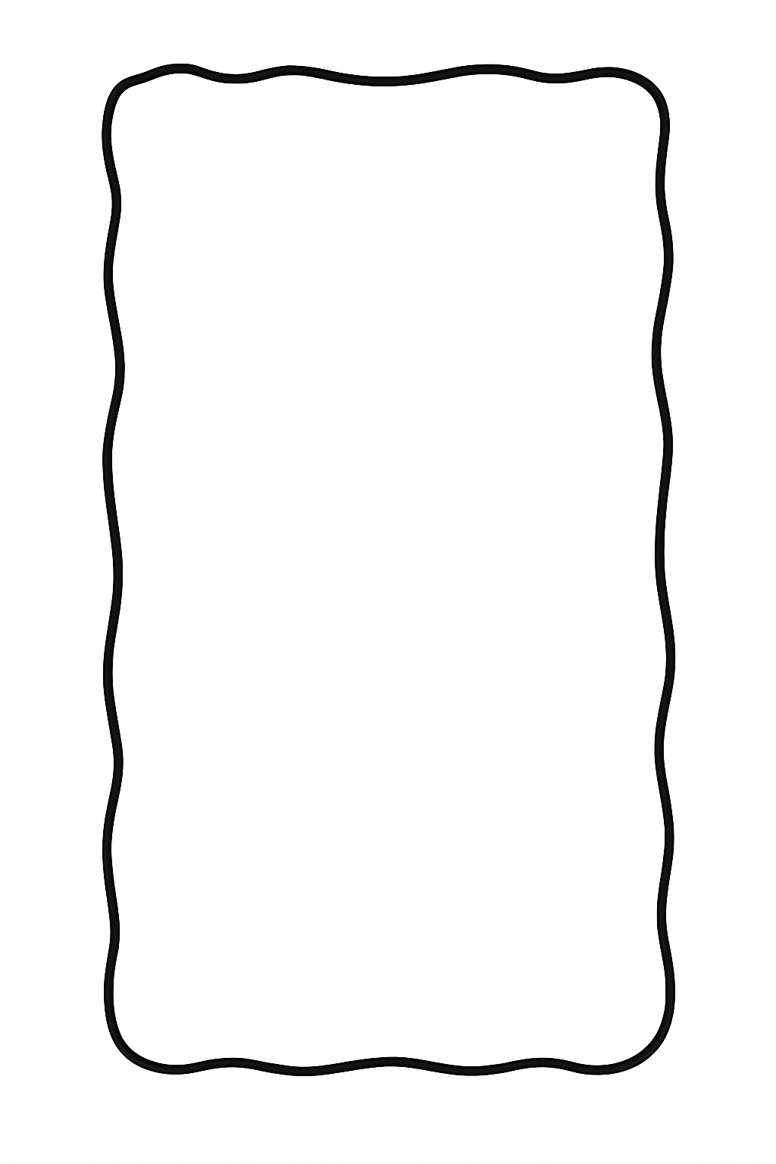
Smooth circle Rectangle geode Other _________

Colour Theme: |  | Edges of tray coloured in theme? | Yes  No  Only thin edge on top
Handle type | Vintage/modern/clear

VINYL STICKER PERSONALISATION ON THE TRAY
Names of couple: |  | Date of event:
Sticker colour: |  | *Please only write in the sections if you want personalisation
Quote or Bismillah calligraphy? (+$15) | Quote?  Bismillah calligraphy?
If selected, what is the quote?
PERSONALISED RIBBON
Ribbon colour: |  | Sticker colour:
Font style: | Fancy | Modern

ACCESSORIES
Type of Scissors: | Vintage | Heart shape
Type of ring holders | Glass with stand | Round mirror | Resin | Glass hexagon (+ $20)
Small preserved flower bunch (+$15)

Quoted price:

Groom’s Coffee Tray (if selected)
Please highlight the tray shape:
Round geode Straight rectangle Oval geode
Smooth circle Rectangle geode Other _________

Colour Theme: |  | Edges of tray coloured in theme? | Yes  No  Only thin edge on top
Handle type | Vintage/modern/clear

ACCESSORIES
Please ask for available selection and write it below.
Coffee Cup Style: | Modern | Traditional | Water glass style: | Modern | Vintage
Lokumluk style: | Glass | White | Gold | Anything else:

VINYL STICKER PERSONALISATION
Sticker colour:
Writing on the tray? | Please write what you want on the groom’s tray:
Font style? | Modern | Fancy

Additional Notes or Requests

Date of order:
Thank you for your order!
We will contact you shortly to confirm your design and final pricing.
Luxish Homeware

